Area Subdivision Algorithm

It was invented by John Warnock and also called a Warnock Algorithm. It is based on a divide & conquer method. It uses fundamental of area coherence. It is used to resolve the visibility of algorithms. It classifies polygons in two cases i.e. trivial and non-trivial.

Trivial cases are easily handled. Non trivial cases are divided into four equal subwindows. The windows are again further subdivided using recursion until all polygons classified trivial and non trivial.

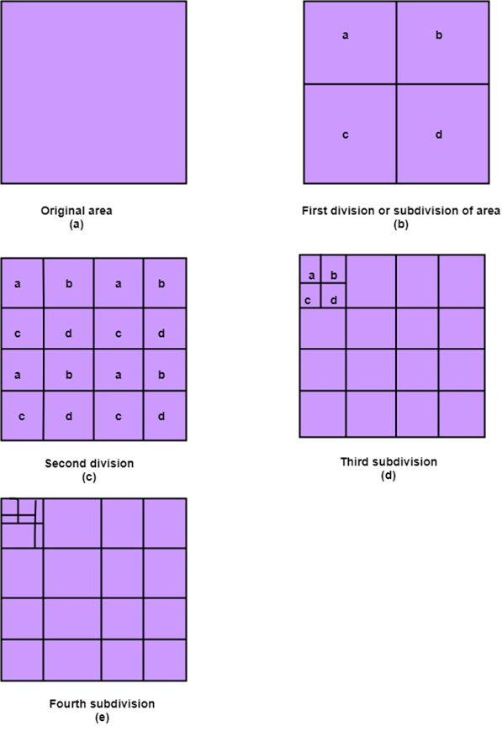

Classification of Scheme

It divides or classifies polygons in four categories:

1. Inside surface
2. Outside surface
3. Overlapping surface
4. Surrounding surface

**1. Inside surface:** It is surface which is completely inside the surrounding window or specified boundary as shown in fig (c)

**2. Outside surface:** The polygon surface completely outside the surrounding window as shown in fig (a)

**3. Overlapping surface:** It is polygon surface which completely encloses the surrounding window as shown in fig (b)

**4. Overlapping surface:** It is surface partially inside or partially outside the surface area as shown in fig (c)

